JavaScript & CSS Menu Exercise
In this exercise you experiment with JavaScript & CSS Menu. You will add a CSS menu to this website and use JavaScript to display this menu. You can find the solution from demo website week 3

- Create menuStyle.css to add the following CSS code to define the style for a menu list, this code can be discussed in the class:

/* menu */
ul.menu
{
float:left;
padding:0;
margin-top:0px;
margin-left:0px;
margin-right:0px;
margin-bottom: 50px;
list-style-type:none;
}
ul.menu a
{
float:left;
width:140px;
text-decoration:none;
font-weight:bold;
font-size:16px;
color: #BFCFEC;
background-color: #05045F;
padding:0.2em 0.2em;
border-bottom:1px solid #BFCFEC;
}
ul.menu a:hover {background-color:#BFCFEC; color:#05045F;}
- Creat index.html file, add the following HTML code inside the <div id="left"> block to create the menu list (at the top) :
<!-- menu -->
<ul class="menu">
<li><a href="home.html">Home</a></li>
<li><a href="about.html">About</a></li>
</ul>

- The output for this part should be similar to the following:

- To make the menu easily extended and displayed on the other pages, JavaScript is helpful. Create an external JavaScript file menuStyle.js and define the following code inside menuStyle.js, this code should be discussed in the class:

// JavaScript Document
var length = 2; //the total number of web pages

var page_tray = new Array(); //an array to hold the page name and the file name

//Load page information into the array
function load_page() {
page_tray[0] = new Array(2);
page_tray[0]['name'] = "Home";
page_tray[0]['file'] = "home.html";
page_tray[1] = new Array(2);
page_tray[1]['name'] = "About";
page_tray[1]['file'] = "about.html";
}

//Write the HTML menu code
function display_menu()
{
//Load the page information
load_page();

//Construct list
var strList="";
strList += "<ul class=\"menu\">";

//This loop is executed to diplay menu items
for (i=0; i<length; i++)
{
strList += "<li><a href=\"" + page_tray[i]['file'] + "\">" + page_tray[i]['name'] + "</a></li>";
}

strList += "</ul>";
document.write(strList);
}
- Modify index.html file, link the external JavaScript to this page by adding the following code inside the <head> section:
<script src="sun-flower.js" type="text/javascript"></script>

- Inside index.html file, inside the <div id="left"> block, replace the menu list code created in step 3 by the following JavaScript block:

<script type="text/javascript">
display_menu();
</script>

- Repeat steps for file about.html. Test the website.
- Save index.html as contact.html, change the heading to “Contact Us”, change the other text in the <div id="middle"> block into the flowing:
<table>
<tr>
<th>Phone</th>
<td>+64 9 849 4180</td>
</tr>
</table>
<h3>Postal address</h3>
<address>
Unitec Institute of Technology<br>
Student Central<br>
Private Bag 92025<br>
Victoria Street West<br>
Auckland 1142
</address>

- Modify JavaScript menuStyle.js to include the Contact page in the menu list. Set var length = 3; add the following code inside function load_page():

page_tray[2] = new Array(2);
page_tray[2]['name'] = "Contact";
page_tray[2]['file'] = "contact.html";

- Test the Contact page, the outcome should look similar to the following:
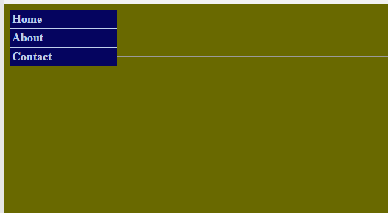

- The link for the Contact page should show up in the Home page and the About page as well.

