Student name:
ID :
Identification of Electrical Gears and Fittings

Please fill out the name in the table using the words below;

- Edison type lamp holder
- BC type lamp holder
- BC type batten holder
- Ceiling rose
- Earth tag
- Main Isolator
- Miniature circuit breaker(MCB)
- Residual-current device(RCD)
- Hot water switch
- Oven switch
- Single gang switch
- 10A power outlet
- 15A outdoor power outlet
- Stove power outlet
- Permanent connection unit(PCU)
- Screw type wire connector (terminal block)

Image | Symbol | Name | Functions
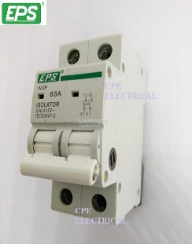
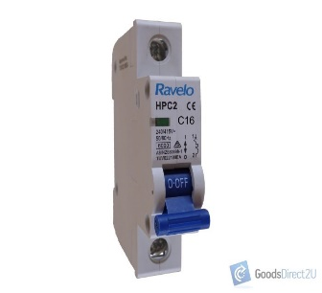
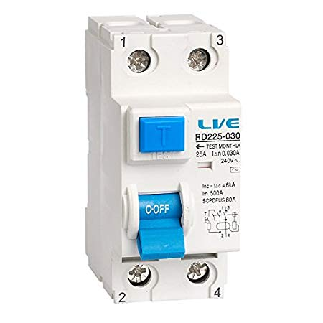

Image | Symbol | Name | Functions
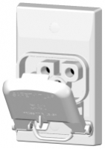
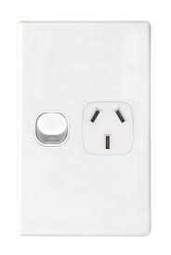
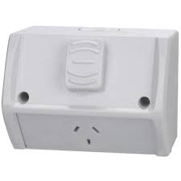
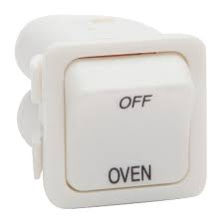
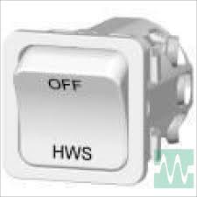
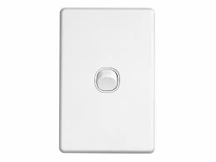
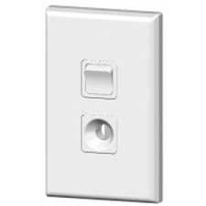

Image | Symbol | Name | Functions
      
