Week2 – 2 CSS and JavaScript
JavaScript can change the style of an HTML element.
Please test your page after each step and compare with online example,
Please use w3school website for your references.
http://www.w3schools.com/

Example 1 – Change text colour and font size
 | 

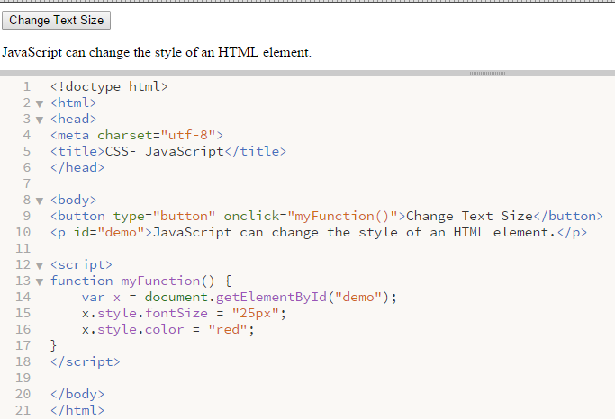
JavaScript change CSS style property.

Example 2 –Colour picker and JavaScript to change CSS property

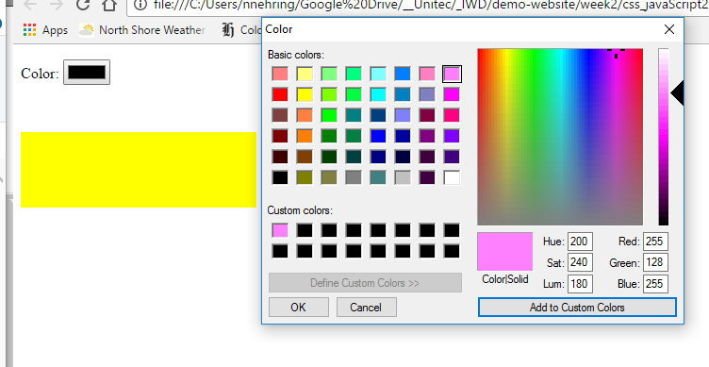

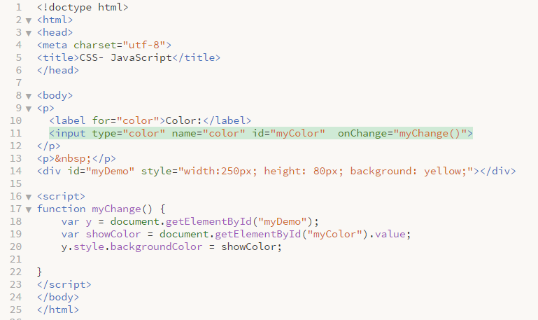

Example 3 –Colour picker and JavaScript to change CSS property

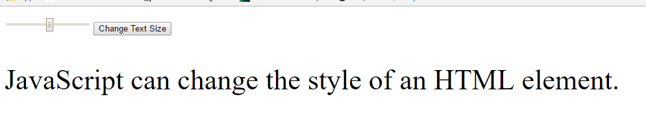
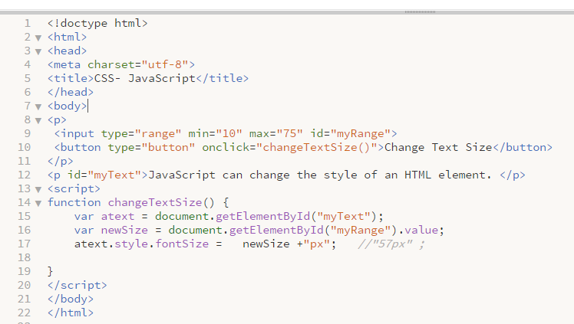

Example 4 –Selector and JavaScript to change CSS property
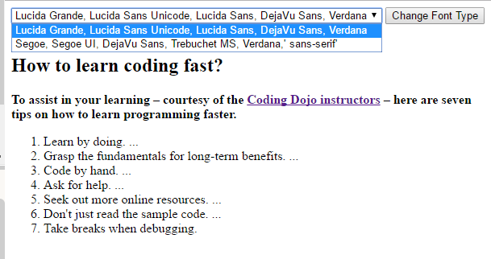
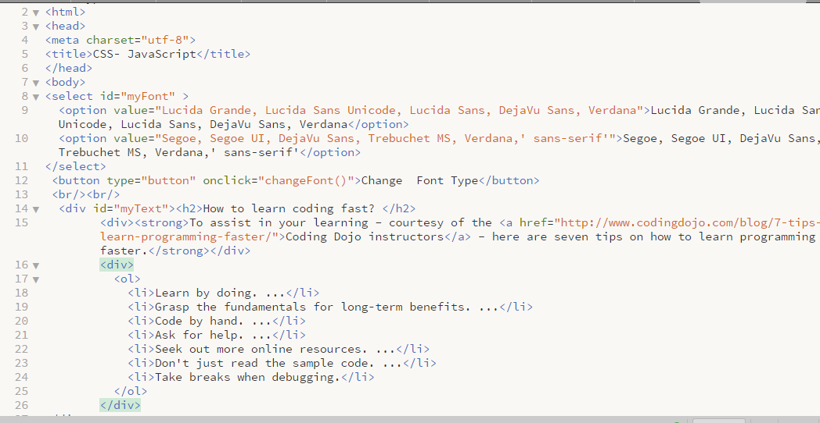
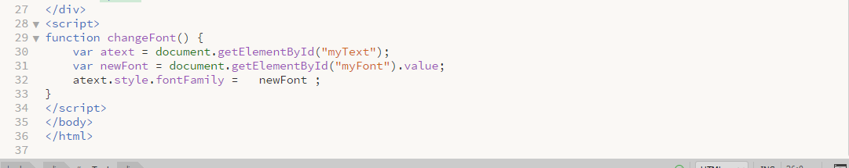

Practice

Task 1 – Make a HTML page with two different range input elements, one will define width and other range will define height for <div> and one colour picker will define background colour for this <div>, and a second colour picker will define a font colour for this <div>

Task 2 – Make a HTML page with range and colour picker and a font type selector, font weight selector to change a CSS for elements (<p>, <div>)

