Decision Making Methods for Teams
- Posted by michael cardus on February 27, 2010 at 5:15pm
- View Blog
Decision Making Methods for Teams
While a decision within organizations often relies upon facts and data, teams must agree upon a method for making decisions based upon the data.
Ensuring that the decisions made are done with a process and purpose
that the team can utilize to make the best possible decision with the
given facts and data.
There are many different decision making styles, two methods must be chosen to serve as guideposts for decisions made. The primary method must be agreed to
by the team and a back up method must also be chosen. The methods can
and will vary upon the people and stakeholders making the decision as
well as the knowledge of the facts and data that the team possesses
when making the decision.
Below is a decision making spectrum as well as the advantages and disadvantages of each method.
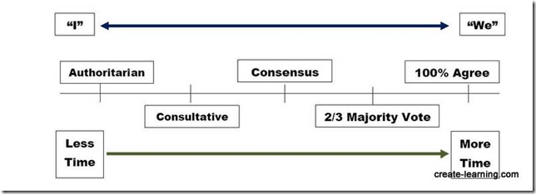
Authoritarian
Authoritarian decision making is a decision that is placed within the hands of one person who chooses quickly and without regard for input from others.
Typically this method is utilized when either there is a crisis and
calls for an immediate decision or when the decision is mundane in
nature.
Advantages and uses;
• Quick decision made when the leader may possess more information than those being affected by the decision.
• When the authority figure has the trust and “best interest” of those who are affected by the decision.
• The speed of the decision being made, decision can be made quickly
• Decision is not watered down with compromises
Disadvantages;
• Decision lacks involvement of those who are affected
• Those affected have decreased chance of “buy in” to decision made
• Chance of incorrect decision based upon poor judgment and incorrect facts
Consultative
Consultative decision making is the type where decision making power is in the hands of one person and the person actively solicits the ideas, suggestions,
and opinions of others.
Advantages;
• People who are affected by the decision are sought out for their input, allowing for greater buy-in to the ultimate decision made.
• By seeking input from varied sources a better and more knowledgeable decision can be made
Disadvantages;
• It takes longer
• Buy-in of the ultimate decision with the consultative method only occurs if your input is finally decided on by the decision maker
• If the decision maker already has a pre-determined choice in mind and
is only “going through the motions” showing a false consultative style,
this method backfires rapidly.
Consensus
Many misconceptions haunt consensus; it is not a tool in total agreement among the team, nor is it a type of voting.
Consensus is a decision making method where all parties involved have input of the decision to be made and whatever agreement is reached (i.e.,
compromise) will not be sabotaged by the team.
Advantages;
• Full participation by the entire team; involves total involvement of the team
• Total participation increases buy-in to the decision made
• With input from the total team the ultimate decision is not made until there is agreement therefore showing total buy-in from all team
members.
Disadvantages;
• Necessitating buy-in from the total team take a longer time frame
• Final decision made are often “watered down”

Majority Vote
Consensus will often prove to not be a viable option. Therefore a backup is needed; usually majority vote is a suitable back up. Majority voting is
rarely ever used as the primary decision making method.
Advantages;
• Decision can made with a less watered down solution
• Speed of decision can be increased, following a lengthy consensus process
Disadvantages;
• Voting creates winners and losers
• Those who lose may be more inclined to sabotage the decision, creating the possibility that whatever decision reached will not be properly
implemented.
100% Agreement
It is a rarity when a diverse team is asked to make a decision that 100% agreement is ever truly reached.
Thus it is strongly recommended that this method should never be used, not even as a back-up.

Michael Cardus
Source: http://www.nasaga.org/profiles/blogs/decision-making-methods-for

