ISCG5430

Professional Skills for IT Professionals

Getting the most out of your word processor

In IT you have to be able to use a word processor well. Not only will you use it to create your own documents, but you may also need to train end-users in the tasks required to produce good word-processed documentation.

A document that has been word-processed correctly will take less time to create and modify than one that has been badly put together. Let the word processor do the work by making use of the functionality provided.

Assess your skills in MS Word by doing the exercises below. Where you do not have the skill, use the on-line help, Google or books to find out how to carry out the task.

Working with Styles
A style defines the attributes of the text that you use in your document including: font face, size and colour etc. All the text in your document will have an associated style. If you use styles correctly, when you can change one of the attributes of a style and all the text associated with that style should change to match the new appearance.

Using Styles
  - Open a blank document.
  - Copy and paste in the following text:

Profitability Report
Entire Firm
Individual Departments
Bankruptcy Corporate
Health Care
Immigration
Trust and Estate
Franchised Departments

  - Using the styles, apply the following styles to the text as shown below

Profitability Report | Heading 1
Entire Firm | Heading 2
Individual Departments | Heading 2
Bankruptcy Corporate | Heading 3
Health Care | Heading 3
Immigration | Heading 3
Trust and Estate | Heading 3
Franchised Departments | Heading 2

  - Change the Heading 2 style to:
    - Font: Algerian
    - Line Spacing: Double
    - Box around the heading

If you have done this correctly, the text that has Heading 2 style (ie “Entire Firm” and Individual Departments” and “Franchised Departments”) will have changed automatically to reflect the new style.

  - Save the document, keep open for the next exercise

Overriding styles
However if you override a style for some text by manually changing one of its attributes (e.g. font size ) then Word will maintain that change if you change its style.
- In the table below we have created a new style called ‘TaskSheetStyle’ but overridden this in every line by changing either the font, font size or another of its attributes so every line looks different but is still attached to a same style.

Profitability Report <base style>
Entire Firm <Change font to add Bold>
Individual Departments <Change font face>
Bankruptcy Corporate <change face and size>
Health Care <Change to add italic>
Immigration <change to add cross through>
Trust and Estate <change font face>
Franchised Departments <change font size>

- Now change the TaskSheetStyle font face to “Verdana’ size to 11 and you will find that the base style will change unless you forced a change, so if you added bold then Word will show your text as Verdana Bold similarly with the font size, if you changed it to a different size then that new size will be maintained whatever the size of the style. If you changed the font face then Word will not change your text to Verdana but keep the formatting that you manually applied. So Word will maintain the attribute that you manually applied, this means that you can no longer simply change the style and have all the text in the document adopt the new style. You should avoid overriding styles, it is better to let the style drive the appearance of the text and if you want a different appearance then change the style, not the text.

Table of Contents
The other reason it’s beneficial to use styles is because Word will select the items to include in your Table of Contents based on its style.
- Change the Table of Contents properties so that :
- Only headings 1 and 2 will shown
- Heading 1 is shown in Arial Black font
- Insert page breaks so that the headings are on separate pages
- Insert a table of contents for the document created in the previous exercise
- Insert a title page.
- Insert another heading on the third page and update the TOC.
- Save and close the document.

Page numbers
You should always add page numbers if your document is more than a couple of pages. This can be very simple using the insert page number function. This will place a page number in the footer or header in the same position for all pages however if your document is printed double sided then it is normal to show your pages numbers on the outside of the page which means you will need to change the position for odd and even pages. It is also helpful to supress the page number on the title page.

- Set up pages numbers as follows:
- Page numbers appear on the left side on even pages and on the right on odd pages
- Make sure the number of pages appears.
- There is no page number on the title page.

Create two news-paper style columns
- Download word_text_columns.doc from Moodle
- Change the layout so that it appears in two new-paper style columns.
Note that the second column starts with “At the same time…” and that the columns are the same width. 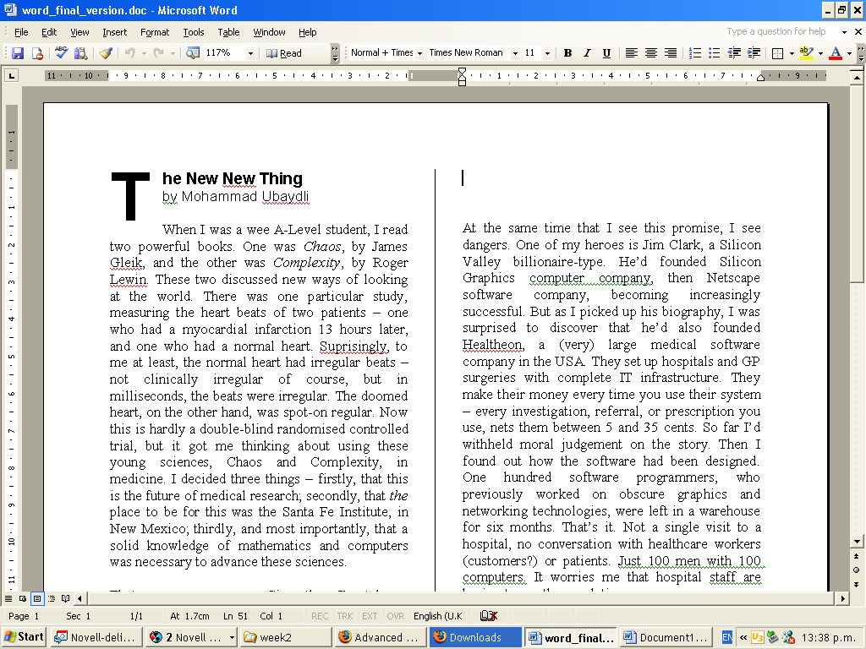
- Save and close the document.

Creating a table
- Using MS Word, create the Table shown below and enter the data in this table. Note that the first row is light grey.

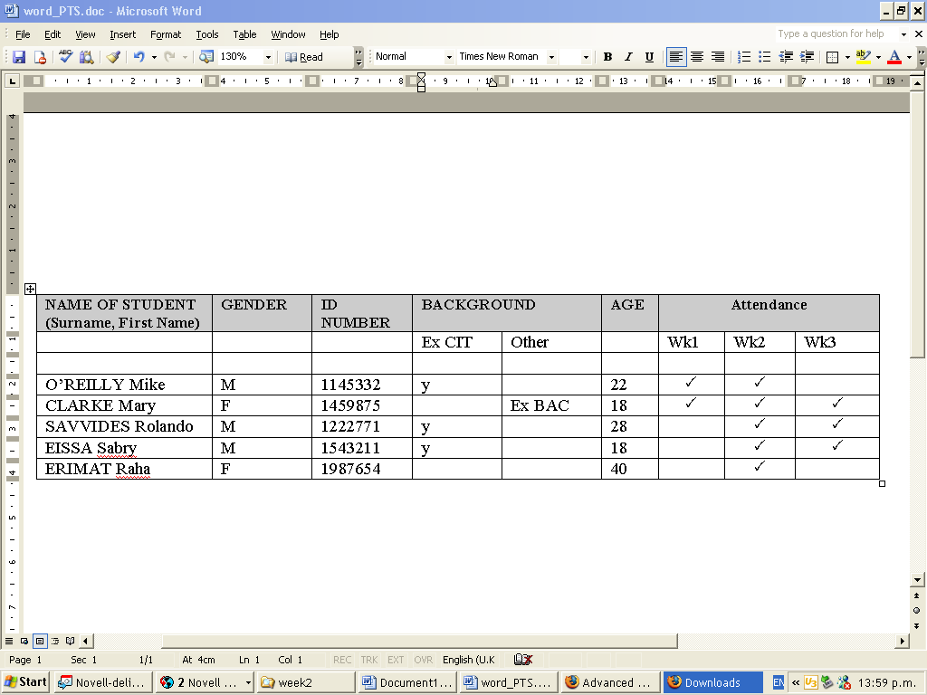

- Save and close the document

Modifying tables
- Download word_text_table.doc from Moodle
- Fix the formatting to make it look like the table below and correct the spelling mistakes
Note: The text line above the table; the removal of a blank row (2nd row); the alignment of text within each cell; the aligning of columns.

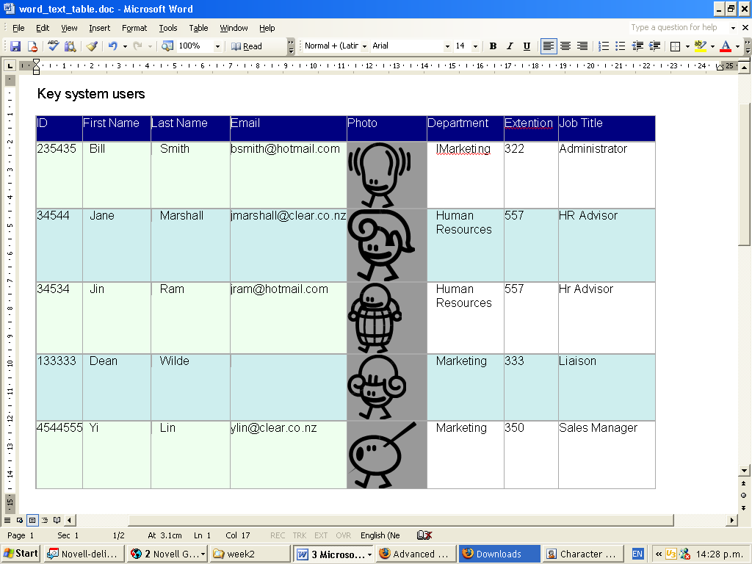

- Save and close the document

Including a spreadsheet in a Word document
The table below can be created using the functions of Word however Word is very limited in terms of the calculations that is has available. A better solution therefore is to inserted a spreadsheet into the document, just by double clicking the sheet will open Excel and enable you to edit the contents of the table.

To insert a spreadsheet use insert\object\MS Excel worksheet.

Using custom bullets or numbering
It’s often useful to have bulleted text that use your own words for the bullets. For example, the text below uses the word ‘Step’ before each of the automatically generated number.
- Open the CRM system
- Select the search function to fine the customer of interest
- Enter the customer details
- Look-up the customer’s contact details

- Click the button beside the numbering option and define a new numbering format
- Choose your number format and type your personalised text before or after the number to have it appear on every line.

SmartArt, screenshots and screen clips
These two features are very useful for documentation. SmartArt (see example below) helps you draw charts and different kinds of diagrams it’s also available in Powerpoint. The Screenshot option (see below) let you capture images from the screen, either the entire screen (screenshot) or part of the screen (screen clip). These are great for writing documentation and both are available on the Insert ribbon.

Example of a SmartArt object

A screen clip taken from Access

