**CIBC5022 Site Preparation and Analysis** - **Levelling Activity Outside 113-4003 May 2022**

**Group Number …………………………………………………**

**Persons Name ……………………………………………………Persons ID Number …………………………………………..**

**Persons Name ……………………………………………………Persons ID Number …………………………………………..**

**Persons Name ……………………………………………………Persons ID Number …………………………………………..**

**Persons Name ……………………………………………………Persons ID Number …………………………………………..**

**Persons Name ……………………………………………………Persons ID Number …………………………………………..**

**Persons Name ……………………………………………………Persons ID Number …………………………………………..**

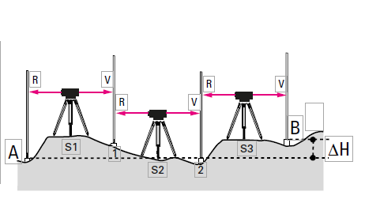

1. **Set up the instrument at S1 using the Building 113 Forecourt (Datum Pt A concrete sign plinthe)**
2. **Take back sight at A with Staff Reading R and record height in line 1.**
3. **Set up the staff precisely vertically at point B white peg in ground at 1; read off and record this height (in Foresight V line 2).**
4. **Set up the staff at the turning point 1 (white peg in ground at 1); read off and record the height (foresight V at point 1 on line 3).**
5. **Then set up the instrument at S2 (the staff remains at the turning point 1).**
6. **Carefully rotate the staff at the turning point 1 so that it faces the instrument.**
7. **Read off the back sight at point 1 and enter into line 4 and continue.**
8. **The height difference between A and B is equal to the sum of the back sight and the foresight.**

|  |  |  |  |  |  |  |  |  |
| --- | --- | --- | --- | --- | --- | --- | --- | --- |
| **Enter Readings Here** | | | | | | | | |
| Line | Back Sight | Intermediate Sight | Foresight | Rise | Fall | Reduced Level | Distance | Remarks |
| 1 |  |  |  |  |  |  |  |  |
| 2 |  |  |  |  |  |  |  |  |
| 3 |  |  |  |  |  |  |  |  |
| 4 |  |  |  |  |  |  |  |  |
| 5 |  |  |  |  |  |  |  |  |
| 6 |  |  |  |  |  |  |  |  |
| 7 |  |  |  |  |  |  |  |  |
| 8 |  |  |  |  |  |  |  |  |
| 9 |  |  |  |  |  |  |  |  |
| 10 |  |  |  |  |  |  |  |  |