**Test Driven Development – using java-script**

The program takes three numbers as an input. These numbers are representing the size of the sides of a triangle. When the user clicks button “submit” the program displays the type of triangle. (As extra: It is possible to add a picture of the triangle as output)

**TDD** is an approach to writing software where you write tests before you write application code. Think what you want to achieve and how you will structure your code. The basic steps are:

**Red: Write a test and make sure it fails.**

Example:

assert.strictEqual(myTriangle(3, 3, 3), 'wrong input', ' as user put 3, 3, 3 we expect An equilateral triangle');

**Green: Write the simplest, easiest possible code to make the test pass.**

Example:

assert.strictEqual(myTriangle(3, 3, 3), 'An equilateral triangle', ' as user put 3, 3, 3 we expect An equilateral triangle');

**Refactor: Optimise and/or simplify the application code, making sure that all the tests still pass.**

Once we finish step 3, we start the cycle again by writing another test.

___________________________

Triangles can be classified according to the lengths of their sides:

**An equilateral triangle** has all sides the same length. An equilateral triangle is also a regular polygon with all angles measuring 60°.

**An isosceles triangle** has two sides of equal length. An isosceles triangle also has two angles of the same measure.

The 45–45–90 right triangle, is isosceles.

**A scalene triangle** has all its sides of different lengths. Equivalently, it has all angles of different measure.

**A right triangle** is also a scalene triangle if and only if it is not isosceles.

Example:

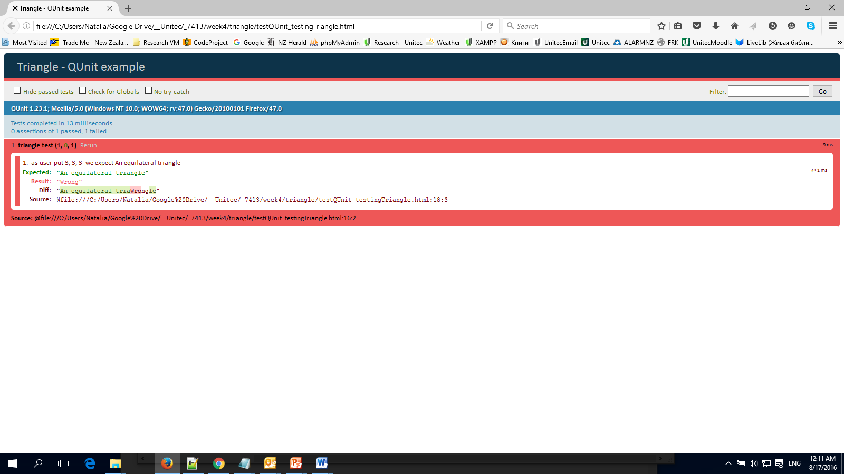

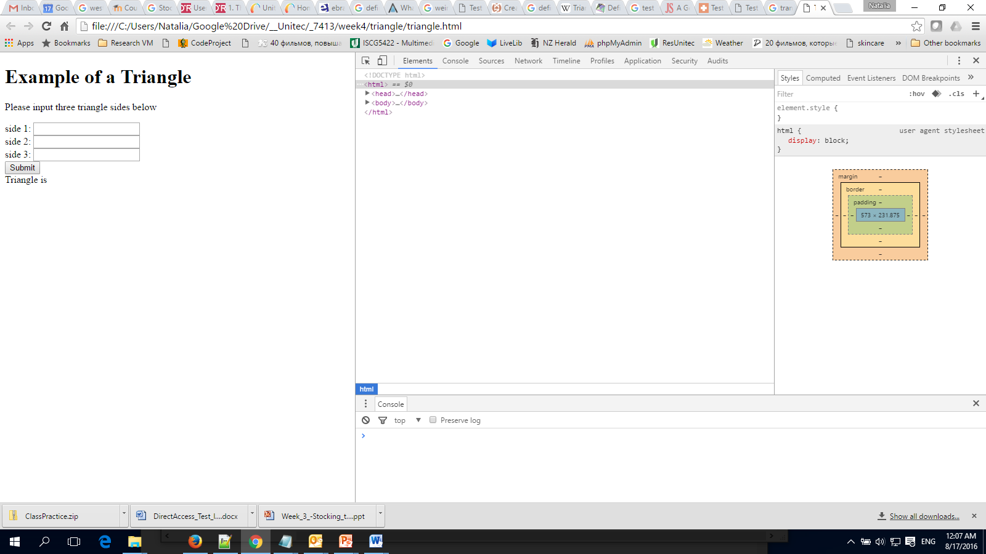

References:

<https://en.wikipedia.org/wiki/Triangle>

<http://jrsinclair.com/articles/2016/gentle-introduction-to-javascript-tdd-intro/>

<http://code.tutsplus.com/tutorials/test-driven-javascript-development-in-practice--net-16246>

<http://thejackalofjavascript.com/test-driven-development-by-example/>

<http://www.w3schools.com/tags/canvas_lineto.asp>

<http://www.chrislinford.co.uk/get-going-guides/HTML5/drawatriangleont.html>