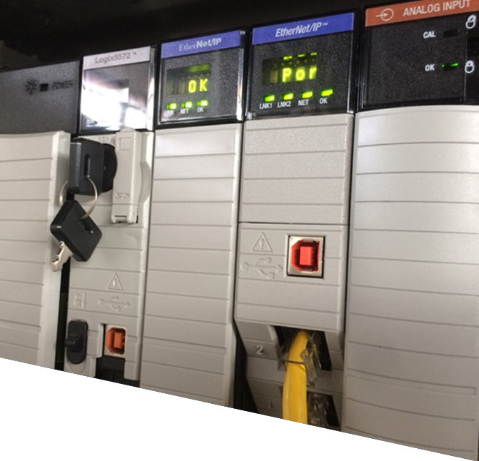

Off-job Assessment

(

practical)



**5926v6**

**Theory**

**–**

**v2.0**



**Electrical Apprenticeship**

**Demonstrate knowledge of programmable logic controllers (PLCs)** (level 4, credits 3)

|  |  |
| --- | --- |
| Trainee Name: (First/Last) |  |
| Company/Employer: |  |
| National Student Number (NSN): (if known) | Skills Number: |
| Phone Number: | Email: |



This document is strictly confidential and the contents must not be disclosed to any unauthorised persons or used in any unethical or illegal manner. This document is protected by Copyright Act 1994 © and is not to be copied or reproduced in any form unless written permission is given by The Skills Organisation Incorporated.

# Introduction

## In this assessment

This is a practical assessment to be arranged at the convenience of the training provider.

Your training provider will provide the necessary equipment for you to use in this assessment.

* A PLC program must be written and tested.

You must demonstrate that you can follow manufacturers’ specifications and installation instructions to write and test a PLC program which complies with the given functional description.

* The running programmes must be observed by the Assessor/Tutor.

This assessment covers part of Unit Standard 5926 v6. You must also complete a theory assessment to be awarded the Unit Standard.

The Unit Standard is for people in the electrical and related trades, who need to be able to demonstrate knowledge of programmable logic controllers (PLCs).

A copy of the unit standard can be found on the NZQA website [http://nzqa.govt.nz/.](http://nzqa.govt.nz/) Each question has a cross reference to the appropriate Unit Standard evidence requirement (ER).

## Legislation and Safety

It is very important for your own safety and the safety of colleagues and customers that you follow safe and sound practice when completing electrical work. Safe and sound practice relating to the installation of electrical equipment is defined in AS/NZS: 3000:2007, Electrical Installations (known as the Australian/New Zealand Wiring Rules).

You may refer to current legislation and Standards (such as AS/NZS: 3000:2007) during assessment.

All activities and evidence presented must comply with legislation, policies and procedures, ethical codes, Standards (such as those listed in Schedule 2 of the Electricity (Safety) Regulations 2010), site/industry practice, and any manufacturer’s instructions, specification and data sheets.

## Assessor/Tutor sign-off

The Assessor/Tutor will observe you completing this assessment.

Your assessor may discuss the outcome of this assessment with you. As with all Unit Standard assessments, you need to prove that are competent in all parts of the Unit Standard.

Your assessor / tutor will advise you if you need to provide more evidence to prove your competence. This may be done verbally. They should make notes of any discussions you have regarding this assessment.

# Pre-assessment form

Please complete the following, before starting the assessment.

|  |  |  |
| --- | --- | --- |
| I have completed/produced the following | **Yes** | **No** |
| I understand what is required to achieve competency in this assessment. |  |  |
| I understand what I need to do to submit my assessment material when I have completed it. |  |  |
| I have the knowledge to complete each question. |  |  |
| I understand how I will get my results. |  |  |
| I understand how the appeals process works. |  |  |
| I understand that my results will be reported to NZQA. |  |  |
| I have informed my assessor about any special needs that need to be accommodated. |  |  |

# Assessment

Design, write and store a PLC program.

You must demonstrate that you can follow the programming language rules, by designing, writing, storing and running a PLC program.

You are required to design a PLC control circuit for an electric roller door in a factory. The program must comply with the following functional description.

Functional description of the garage door controller.

1. When the Up Push Button (PB1- N/O) is pressed the door must raise until the Upper Limit Switch (LS1- N/O) is reached. When LS1 closes the door must stop.
2. When the Down Push Button (PB3 – N/O) is pressed the door must lower until the Bottom Limit Switch (LS2 – N/O) is reached. When LS2 closes the door must stop.
3. The door is to complete raising or lowering to the limit switch if the up or down button is released. An interlock should prevent the roller door attempting to open and close at the same time.
4. The door is to stop if the Stop Push Button (PB2 – N/C) is pressed.
5. A Motor Indicator Lamp (L1) must come on if the motor is running.
6. The door only takes 15 seconds to complete operation. The door must stop if it runs for more than 20 seconds without activating one of the limit switches and an Alarm Indicator Lamp (L2) must come on to show a fault
7. L2 must be reset when an up or down control is activated.

*(ER 2)*

## Design, write and store a PLC program Assessor/Tutor observation checklist & sign off

|  |  |
| --- | --- |
| **I confirm that the trainee:** | **Tick** |
| Designed wrote and downloaded the program to the PLC | ☐ |
| Followed programming language rules. | ☐ |
| Matched symbols and addresses. | ☐ |
| Ran and verified the program | ☐ |
| Saved the program | ☐ |
| Documented test results with a printout of the program (optional) | ☐ |

|  |  |  |  |
| --- | --- | --- | --- |
| **Assessor/Tutor sign** |  | **Date** |  |

|  |
| --- |
| **Written feedback from Assessor/Tutor** |
|  |

# Trainee sign off

**Sign before giving this assessment and evidence to your assessor**

|  |  |  |
| --- | --- | --- |
| Trainee name: |  | Skills Trainee Number:  NSN (if known): |

**Declaration:**

I have completed all activities in the assessment.

I confirm that this assessment is my own work.

I understand that there is an appeals process if I am not happy with the assessment decision.

Signature: Date:

# Assessor to complete & sign

**New Zealand Certificate in Electrical Engineering Theory and Practice (Trade) (Level 4)**

**5926 v6 - Demonstrate knowledge of programmable logic controllers (PLCs) (Level 4, Credits 3)**

**Attempt 1**

**Attempt 2**

**Attempt 3**

**Notes**

C

NYC

C

NYC

C

NYC

|  |
| --- |
| **Assessor’s feedback to trainee** |
|  |

I confirm that the trainee has completed this assessment. The work shows a level of competence that is appropriate for the unit standard.

Assessor name: Assessor number:

|  |  |
| --- | --- |
| Signature: | Date: |
| Email: |  |



**The Skills Organisation**

0508

SKILLS

(0508 754 557)

Skills.org.nz