**ORDERING FRACTIONS, DECIMALS, AND PERCENTAGES from smallest to largest.** ⅛⅙⅕**¼**⅓⅜⅖**½**⅗⅝⅔**¾**⅘⅚⅞ ⅛⅙⅕**¼**⅓⅜⅖**½**⅗⅝⅔**¾**⅘⅚⅞⅛⅙⅕**¼**⅓⅜⅖**½**⅗⅝⅔**¾**⅘⅚⅞

**Need to revise ordering decimals? Look at Ex 38, p 50 in green Workbook 1Need some help ordering fractions? Look at the fraction wall on p 42 of Workbook 2**

**To be able to order fractions, decimals and percentages, it may help to refer to this number line:**

**0 0.1 0.25 0.4 0.5 0.75 0.9 1**

**1% 10% 25% 40% 50% 75% 90% 100%**

**I_______I_______I_______I_______I_______I_______I_______I_______I_______I_______I**

**0.01 =**

**When asked to order a group of fractions, decimals and percentages, here are some benchmarks to think about:**

* Is the number close to 0, or very small? e.g. 0.01 (=1% or 1 hundredth)
* Is the number close to or is it less or more than ?
* e.g., is less than while is more than
* Is the number almost 1 whole? How close to 1 whole is it?

e.g. is more than because the missing portion is smaller.

[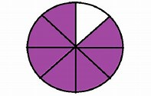](https://www.bing.com/images/search?q=images+of+7+eighth&id=4F7F30A8ED35A0124A5B9ED88DC100B7997233C8&FORM=IQFRBA)[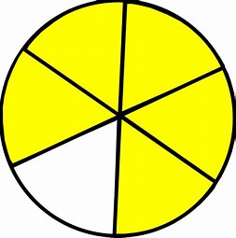](https://www.bing.com/images/search?q=fractions+images+5+sixth&id=35AFE5F90526E1E2A13C068AF01F7E6E3F465748&FORM=IQFRBA)

* Lastly, you might find it helpful to convert some or all the values to decimals (or fractions or percentages where convenient) to be able to compare.

**Example: place these in order from smallest to largest:**

**71% 0.02**  **0.15**

0.02 is the smallest, = 0.125 so is smaller 0.15.

Of the large values, 71% is smaller than (remember is the same as 75%)

So your final order will be **0.02, 0.15, 71%,**

**TRY THE FOLLOWING EXAMPLES: Order from smallest to largest.**

1. 5% 0.3 89% 0.7
2. 25% 0.04 2% 0.78
3. 45% 0.55 0.4 3%
4. 0.7 7% 0.1 0.67
5. 0.5 0.505 49% 0.05
6. 0.9 91% 0.89

**Answers: 1. 5% 0.3** ⅔ **0.7 89%**

**2.** 2% **0.04 25%** 0.78 ⅘

**3.** **3% 0.4 45% 0.55 ¾**

**4. 7% 0.1** ⅓ **0.67 0.7**

**5. 0.05 49% 0.5 0.505 ¾**

**6. 7/10 0.89 0.9 91% 99/100**