**Instructions for Submission – Here are 3 ideas that students have found successful**

This assignment needs to be submitted to Moodle as a **PDF file.**

* Hand write your working and explanations neatly on a piece of paper
* Take a clear photo/s of all your working and explanations.

1. The best way I have found is to create PDF from your phone is to google how to use your camera as a SCANNER. I have an iPhone, so go to the NOTES tile click the camera icon and select SCAN documents. After completing the scanning I save it, then forward as one document to my computer by EMAIL.

2. Use the app below to convert the photo to a PDF and upload

<https://play.google.com/store/apps/details?id=com.microsoft.office.officelens&hl=en>

3. Open a word document. At the top of the page put a title with the assignment number and name and **your name**

Insert your photos into the word document

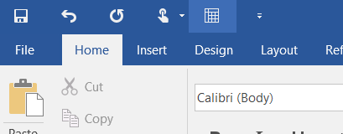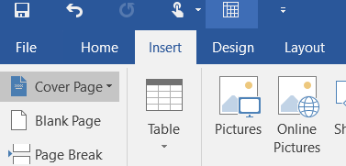

* Click file and save your word document as a PDF ( your computer will ask to save it first as a word file then will save as PDF).

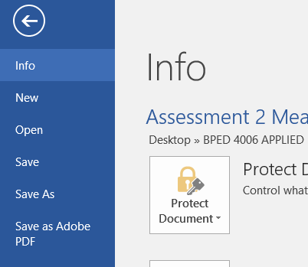 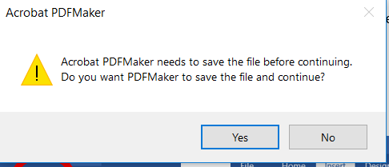

* Upload your file to Moodle