Form Validation Exercises
In this exercise you will learn how to write and use a form validation
H:\BUSINESS\DISC\6420 IWD\exercises\Form Validation Exercises\Solution

Exercise 1| Simple form validation
- Based on the example (simpleValidation.html), please try to read and learn how the example code works. Then, you need to add two more inputs for surname and email address to your form as shown in the following figure.
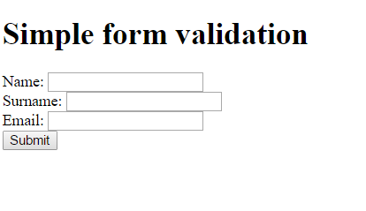

- Modify the code so that the JavaScript form validation can check whether surname and email textboxes have been inputted by a user or not. Then, if there is an error, the alert box with an error message should be displayed.
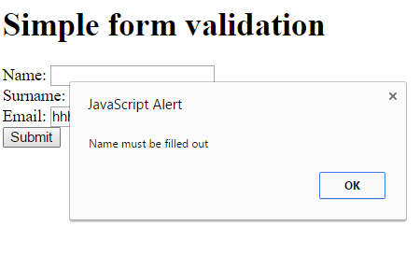

- Once you complete this exercise, save it as simpleValidation1.html

Exercise 2| Validating String and number
- Open simpleValidation1.html. Then, save it as simpleValidation2.html. In simpleValidation2.html, you need to add a textbox for age as shown in the figure.
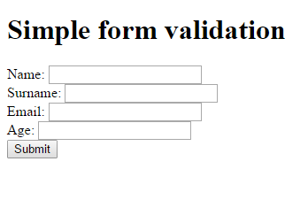

- Modify the code so that the form can validate whether a user has inputted at least 3 characters into name and surname textboxes or not.
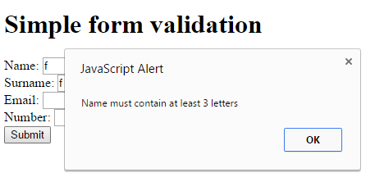

- Now, It‘s time to validate the number. You have to make sure that user can submit only the number between 20 and 100 into an age text box.
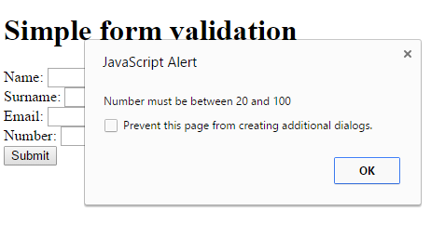

Exercise 3| Using Regular Expression
- Open simpleValidation2.html. Then, save it as simpleValidation3.html. This is the regular expression that we use to check an email pattern.

^([a-zA-Z0-9_\.\-])+\@(([a-zA-Z0-9\-])+\.)+([a-zA-Z0-9]{2,4})+$

- Modify the code so that we can validate an email format inputted by a user.
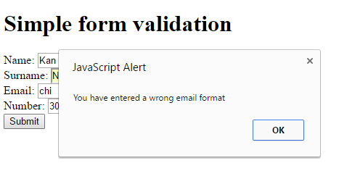

Exercise 4| Validating other types of form element
- Open simpleValidation3.html. Then, save it as simpleValidation4.html.

- In this exercise, you will need to do a bit of research on the internet. I want you to add a drop-down list the web page. It should contain a set of options including select your level (default and has no value), beginner, intermediate, and advance and we label it as level.
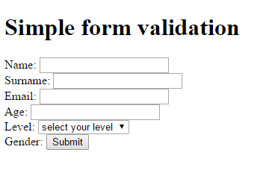

- Modify the code so that the form can validate the new drop-down list and display an error message when a user doesn’t select any option into a drop-down list.
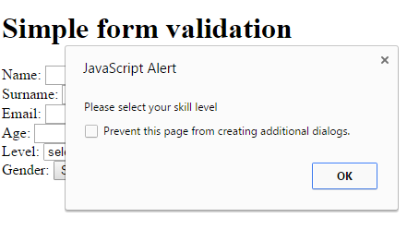

Exercise 5| User-friendly Validation (Extra)
- Open simpleValidation4.html. Then, save it as simpleValidation5.html.
- Modify the code so that the form validation can display all error messages at once as shown in the figure. To complete this exercise, you need to use DOM.

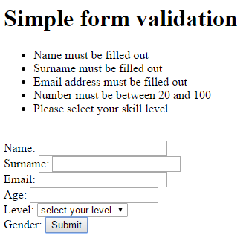
- Once you have completed the above tasks, you now finish all exercise. However I suggest that you can try to improve your code further to support the real-time validation. There will be no answer for this task. If you have the problem with your code, you may a look at the example from the lecture as a guideline.

