HTML5 & JavaScript Validation Exercise
In this exercise, you will experiment with form validation by using javascript in Dreamweaver as well as some of the new input controls available in HTML5.

Instructions
PART A

Create a new Form with the following HTML5 input controls:
- Date, Month, Time, Week, Datetime, Datetimelocal
- Number (min= 1, max=50)
- Range,
- Button
- Color
- Email, Password
- Search, Tel and URL

You can either write the source code or use Dreamweaver’s Insert→Form menu item to create your form. Enter various values (valid and invalid) and see what kind of form validation is provided by HTML5.
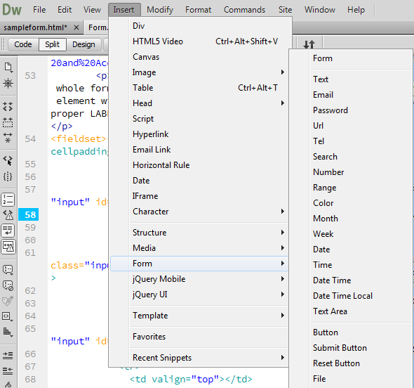
Hint: To find examples on how to create the above input controls refer to the slides for this week or have a look at this link: http://www.w3schools.com/html/html_forms.asp
PART B

Please follow these steps:

- Copy file Validation.html from the following location:

H:\BUSINESS\DISC\6420IWD\exercise\Form Validation

- Open Validation.html in Dreamweaver and view it from a browser. Try to type in some words and click on the “Submit” button and see what happens.

- In this step you will add required field validation to the above page.

- Please type in the following javascript block before the </head> tag, this will define two functions which will check if there is any thing in the input field.

<script type="text/javascript">
function validate_required(field,alerttxt)
{
with (field)
{
if (value==null||value=="")
{alert(alerttxt);return false;}
else {return true}
}
}

function validate_form(thisform)
{
with (thisform)
{
if (validate_required(email,"Email must be filled out!")==false)
{email.focus();return false;}
}
}
</script>

- Please type in the following attribute to the FORM tag:

onsubmit="return validate_form(this)"

- View Validation.htm from a browser. Click on the “Submit” button without input anything and see what happens.

- In this step, you will add email validation to the above page.

- Please add in the following function to the javascript block, this will define a function which will check if the input email address contains a symbol “@” and a “.”. The “.” Must be at least one characters away from the “@”:

function validate_email(field,alerttxt)
{
with (field)
{
apos=value.indexOf("@");
dotpos=value.lastIndexOf(".");
if (apos<1||dotpos-apos<2)
{alert(alerttxt);return false;}
else {return true;}
}
}
- Comment out function validate_form by putting /* */ surrounding it, and replace it by the following code :

function validate_form(thisform)
{
with (thisform)
{
if (validate_email(email,"Not a valid e-mail address!")==false)
{email.focus();return false;}
}
}

- View Validation.htm from a browser. Type in “nbaghaei@” and click on the “Submit” button, see what happens. Type in “nbaghaei@.” and click on the “Submit” button, see what happens. Type in “nbaghaei@u.” and click on the “Submit” button, see what happens.

- Try to do the required field validation and email validation at the same time, how should you modify the code?

