Shopping Cart Exercise
This exercise should be discussed in the class. In this exercise you will practice how to implement a simplified shopping cart by using JavaScript. You will create a shopping cart for an online purchase order system of books. The stock information is provided by an external XML file books.xml.

You can find all the required files for this exercise from the following location, please copy these files to your own folder:
H:\BUSINESS\DISC\6420 IWD\exercise\Shopping Cart Exercise\Supplied Files

You can find a solution of this exercise from the following location:
H:\BUSINESS\DISC\6420 IWD\exercises\Shopping Cart Exercise\Solutions

The outcome of this exercise should look similar to the following:
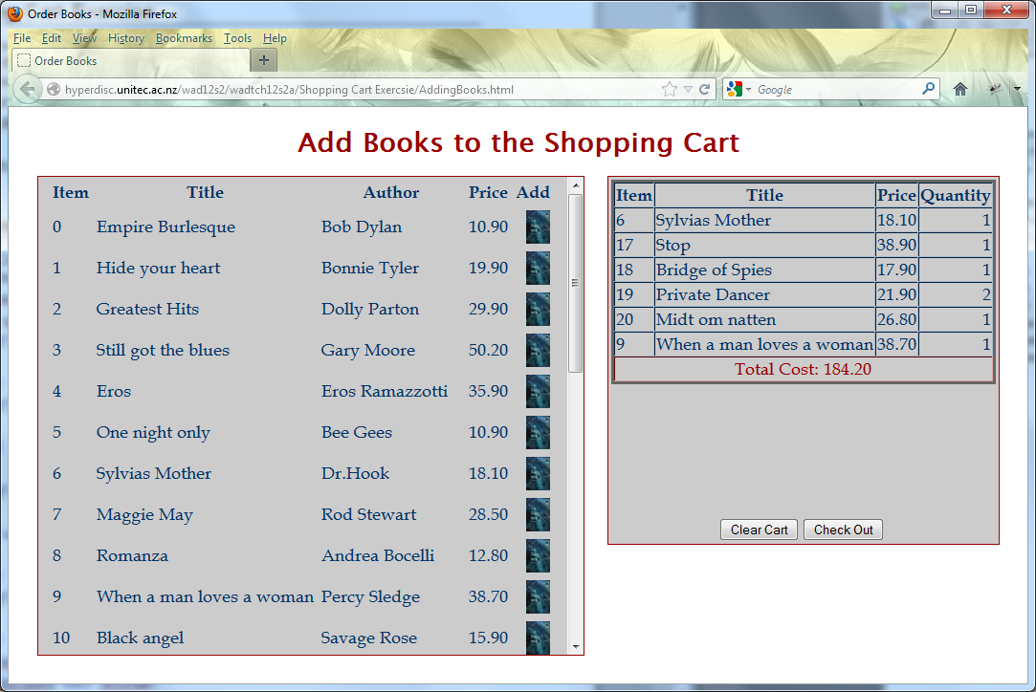

Get ready
- Configure a site in Dreamweaver which is connected to your server account. Please refer to the document Designing with Templates Exercise.doc you have used in Week 6.
- Create a folder Shopping Cart Exercise in your server account and upload all the supplied files to this folder.
- Create a new HTML file ShoppingCart.html in your server folder Shopping Cart Exercise, and attach the given CSS stylesheet shopping-cart.css to this page.
- Create page elements on ShoppingCart.html by using the pre-defined styles. Here is the source code the comments explains the code:
<body>
<h1>Add Books to the Shopping Cart</h1>
<!-- Shopping cart -->
<div id="txtContainer">
<!-- Book Area -->
<div class="display" id="txtBookInfo">
Books
</div>
<!-- Shopping Cart Area-->
<div class="display">
<table align="center">
<tr>
<td colspan="2"><div id="txtCart">Cart</div></td>
</tr>
<tr>
<td align="right"><input type="button" value="Clear Cart" onclick="clearCart();"/></td>
<td align="left"><input type="button" value="Check Out" onclick="checkOut();" /></td>
</tr>
</table>
</div>
</div>
</div>
</body>
- The outcome of this part should look similar to the following:
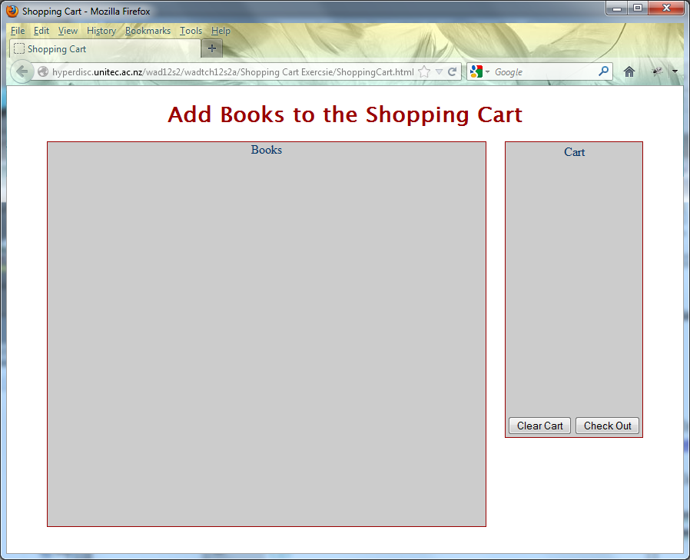:

Load stock information from books.xml
- Create a new JavaScript file shopping-cart.js in your server folder Shopping Cart Exercise, and attach it to ShoppingCart.html.
- Inside file shopping-cart.js, define function loadXMLFile(xmlFile) which takes an XML file as a parameter and converts it into an XML Document object as the return object.
function loadXMLFile(xmlFile)
{
if (window.XMLHttpRequest)
{// code for IE7+, Firefox, Chrome, Opera, Safari
xmlhttp=new XMLHttpRequest();
}
else
{// code for IE6, IE5
xmlhttp=new ActiveXObject("Microsoft.XMLHTTP");
}

//Load the XML file and return an XML object
xmlhttp.open("GET", xmlFile, false);
xmlhttp.send();
return (xmlhttp.responseXML);
}

- Inside file shopping-cart.js, define two global variables to hold the shopping cart later:
var nextItem = 0; //The index of next ietm to be added
var currentCart = new Array(); //This array contains the current items in the cart

- Inside file shopping-cart.js, define function displayBooks() which loads the XML file books.xml and save the data into an XML Document object xmlDoc. It then constructs an HTML table that displays the key information for all the books within <div id="txtBookInfo"> . The comments explains the code.
function displayBooks()
{
//Load the XML file that contains the information for all the books
xmlDoc=loadXMLFile("books.xml");

//Construct a table that displays the key information for all the books
txt="<table border='0px' id='tblBook' cellpadding='3px' cellspace='0px'>";
txt+="<tr><th>Item</th><th>Title</th><th>Author</th><th>Price</th><th>Add</th></tr>";

//Retrieve all the BOOK elements from the XML file
books=xmlDoc.documentElement.getElementsByTagName("BOOK");
for (i=0;i<books.length;i++)
{
txt+="<tr>";

txt+="<td align='left'>" + i + "</td>";
bookChildren=books[i].getElementsByTagName("TITLE");
txt+="<td align='left' id='title"+ i +"'>" + bookChildren[0].firstChild.nodeValue + "</td>";

bookChildren=books[i].getElementsByTagName("AUTHOR");
txt+="<td align='left'>" + bookChildren[0].firstChild.nodeValue + "</td>";

bookChildren=books[i].getElementsByTagName("PRICE");
txt+="<td align='left' id='price"+ i +"'>" + bookChildren[0].firstChild.nodeValue + "</td>";

txt+="<td align='right'><img src='book-icon.jpg' onclick='addToCart(" + i + ");'/>" + "</td>";

txt=txt + "</tr>";
}
txt+="</table>";

//Display book table in <div id="txtBookInfo">
document.getElementById("txtBookInfo").innerHTML=txt;
}

- Inside file ShoppingCart.html, call function displayBooks() before </body> tag:
<script type="text/javascript">
displayBooks();
</script>
- This part of the outcome should be similar to the following, when a book icon is clicked, it will call function addToCart(i) with the item number ,i.e. i, as a parameter.
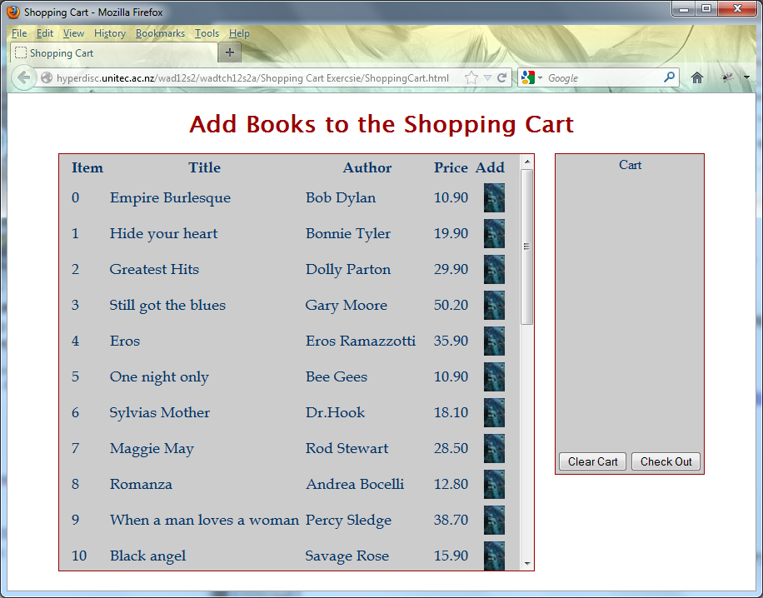

Build the shopping cart
- Inside file shopping-cart.js, define function displayCart() which constructs the shopping cart table from the global array currentCart and displays it within <div id="txtCart">. The array will hold all the selected items within the shopping cart.
function displayCart()
{
//Construct shopping cart table heading
txt="<table id='tblCart' border='5px' cellpadding='1px' cellspacing='0px' align='center' style='margin:0px;border:#666 solid;'>";
txt+="<tr><th>Item</th><th>Title</th><th>Price</th><th>Quantity</th></tr>";
totalCost = 0;
//Construct shopping cart table body
for (i=0;i<nextItem;i++)
{
txt+="<tr>";

txt+="<td align='left'>" + currentCart[i][0] + "</td>";
txt+="<td align='left'>" + currentCart[i][1] + "</td>";
txt+="<td align='left'>" + currentCart[i][2] + "</td>";
txt+="<td align='right'>" + currentCart[i][3] + "</td>";

totalCost += currentCart[i][2] * currentCart[i][3];

txt=txt + "</tr>";
}

//Display the total cost
txt+="<td align='center' colspan='4' style='color:#900;'> Total Cost: " + parseFloat(totalCost).toFixed(2) + "</td>";

//Close shopping cart table
txt+="</table>";

//Display shopping cart table in <div id="txtCart">
document.getElementById("txtCart").innerHTML=txt;
}
- Inside file ShoppingCart.html, call function displayCart() before </body> tag:
<script type="text/javascript">
displayBooks();
displayCart();
</script>
- The outcome of this part should look similar to the following:
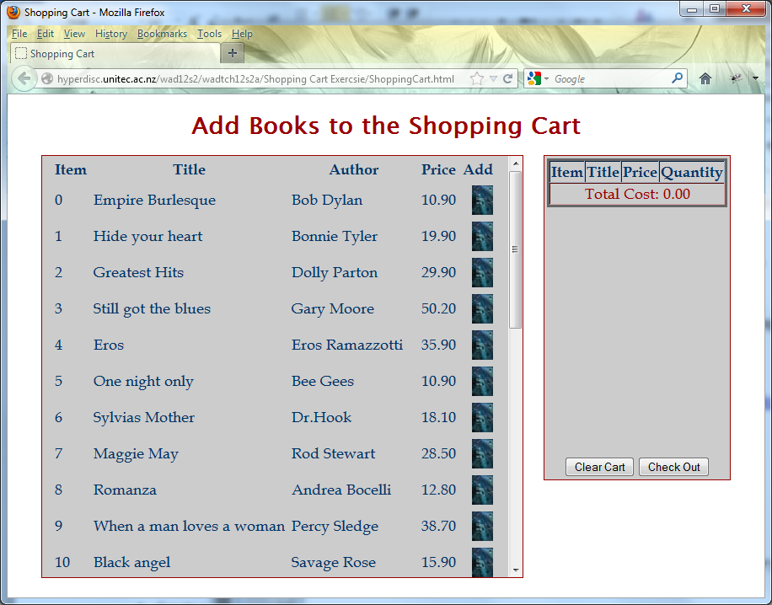
- Inside file shopping-cart.js, define function addToCart(selectedItem) which is called when a book icon is clicked. It checks if the selected item has been added once, if YES then its quantity is increased by one, otherwise, it adds a new item to the shopping cart.
function addToCart(selectedItem)
{
var addedIndex = -1;

//Check if the selected item has been added once
for (i=0;i<nextItem;i++)
{
if (currentCart[i][0]==selectedItem)
{
//The selected item has been added once, record the index
addedIndex = i;
break; //stop looping
}
}

//If the selected item has not been added, add a new item to the shopping cart, otherwise, simply increase the quantity for the item by one,

if (addedIndex == -1)
{
//Create a new item in the shopping cart
currentCart[nextItem] = new Array();

//Put the item details into the shopping cart
currentCart[nextItem][0] = selectedItem;
currentCart[nextItem][1] = document.getElementById("title" + selectedItem).innerHTML;
currentCart[nextItem][2] = document.getElementById("price" + selectedItem).innerHTML;
currentCart[nextItem][3] = 1; //set the quantity

//Get ready to add next item
nextItem += 1;
}
else
{
currentCart[addedIndex][3] += 1;
}

//Refresh the shopping cart
displayCart();
}

- Try to click on some of the book icons, the outcome should be similar to the following:
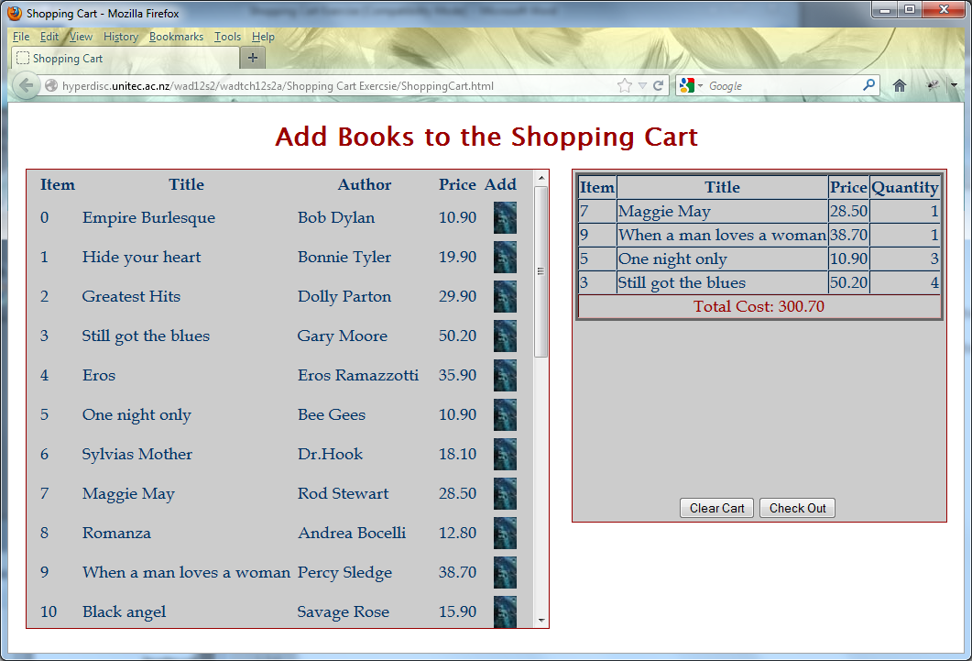

Handle the tow buttons
- Inside file shopping-cart.js, define function clearCart() which is called when the Clear Cart button is clicked. It clears the current item array and refreshes the shopping cart:
function clearCart()
{
//Reinitialise the current item array
nextItem = 0;
currentCart = new Array();

//Refresh the shopping cart
displayCart();
}

- Inside file shopping-cart.js, define function checkOut() which is called when the button Check Out is clicked. It saves the selected items in the shopping cart into an XML document object and clears the shopping cart. It also calls the given PHP file ProcesingOrder.php to save the selected items in an external XML file item.xml, as your account does not have writing permission for PHP code, you won’t be able to see item.xml in your account, however, you can find an example file from the Solutions folder.
function checkOut()
{

//Construct XML string
txt="<ITEMS>";

//Loop through the shopping cart
for (i=0;i<nextItem;i++)
{
txt=txt+"<ITEM>";
txt=txt+"<TITLE>" + currentCart[i][1] + "</TITLE>";
txt=txt+"<PRICE>" + currentCart[i][2] + "</PRICE>";
txt=txt+"<QUTANTY>" + currentCart[i][3] + "</QUTANTY>";
txt=txt+"</ITEM>";
}
txt=txt+"</ITEMS>";

//Save the XML data into an XML object, which could be used by another piece of JavaScript code

if (window.DOMParser)
{
parser=new DOMParser();
xmlDoc=parser.parseFromString(txt,"text/xml");
}
else // Internet Explorer
{
xmlDoc=new ActiveXObject("Microsoft.XMLDOM");
xmlDoc.async=false;
xmlDoc.loadXML(txt);
}

//XML HTTP object
if (window.XMLHttpRequest)
{// code for IE7+, Firefox, Chrome, Opera, Safari
xmlhttp=new XMLHttpRequest();
}
else
{// code for IE6, IE5
xmlhttp=new ActiveXObject("Microsoft.XMLHTTP");
}

//Send the XML string to server
var url = "ProcesingOrder.php?XMLStr=" + txt;
xmlhttp.open("GET", url, false);
xmlhttp.send(null);

//Clear cart
clearCart();
}

- The following is a live solution of this exercise:
http://hyperdisc.unitec.ac.nz/iwd15s2/6229/xli_2015s2IWD/Shopping%20Cart%20Exercise/ShoppingCart.html

