|  |  |
| --- | --- |
|  | **HTML5 Test**  **Semester 1, 2022**  **ISCG6420 IWD**  **Task 1** |
| School of Computing Electrical and Applied Technology | **Date:** Wednesday, 18 May 2022  **Commencement Time:** 6:00 PM  **Time Allowed:** 40 min  **Marks:** 34 |
|  |  |

**Please fill in your name and your student ID.**

|  |  |
| --- | --- |
| Name: | student ID: |

**Instructions:**

|  |  |
| --- | --- |
| 1. | This is semi-open book test. IWD demo website is closed. |
| 2. | There are 3 tasks in this test. Each task is 40 min, you need to upload each task after 40 min. Submission will be allowed for 10 min only. You should complete all the tasks. You should attempt all the requirements. |
| 3 | Please keep each test part in corresponded folder, for example Part_1. Please save all files during the test frequently. In the end of each 40 minutes, re-name your folder with your name (example: Part_1_Mary_popins), Zip this folder and submit. |

**Task 1 Canvas 34 MARKS**

**Instructions**

1. Create an HTML file named whale.html. Based on using HTML5, define a canvas element with the following properties:

Width: 800px

Height: 500px

Border: Chocolate, solid, 10px.

Background: #D9B3FF

(3 marks)

2. Write JavaScript functionality to draw one semi-circle with the following properties:

Colour: #999966;

Radius: 200

Border: 4px, #663300

The semi-circle represents a whale.

(4 marks)

3. Write JavaScript functionality to draw a square with following properties:

Size: 800x100

Fill colour: #0099FF

The square should be representing a sea in the canvas. Please see an example in the next page.

(3 marks)

4. Write JavaScript functionality to draw two yellow circles (eyes of the whale) with the following properties:

fill colour: #FF4000.

Border: 4px, #663300

Radius: 15

(4 marks)

5. Write JavaScript functionality to draw a white semi-circle with the following properties:

Radius: 40

Border: 10px, stroke Style: "white".

The semi-circle represents a smoke from the whale.

(4 marks)

6. Write JavaScript functionality to draw a one rectangle with following properties:

fill colour: #663300

Width=50;

Height=100;

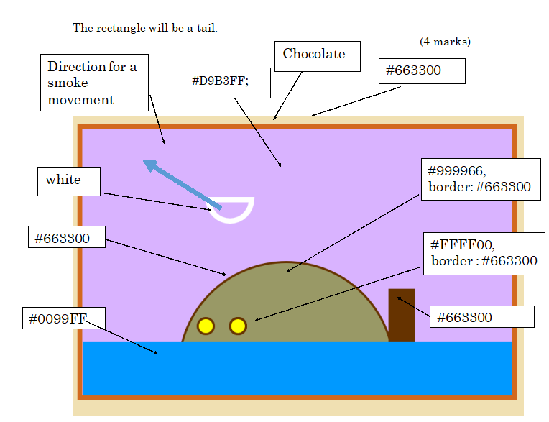

10. Write JavaScript functionality to move smoke cloud diagonally. Set interval (timer) for every 180 milliseconds for its movement. Remember to clear the area of previously drawn smoke semi-circle.

(12 marks)