|  |  |
| --- | --- |
|  | **HTML5 Test**  **Semester 1, 2022**  **ISCG6420 IWD**  **Task 2** |
| School of Computing Electrical & Applied Technology | **Date:** Wednesday, 18 May 2022  **Commencement Time:** 6:00 PM  **Time Allowed:** 40 min    **Marks:** 33 |
|  |  |

**Please fill in your name and your student ID.**

|  |  |
| --- | --- |
| Name: | student ID: |

**Instructions:**

|  |  |
| --- | --- |
| 1. | This is closed book test. Your test files are in Moodle. |
| 2. | There are 3 tasks in this test. You should complete all the tasks. You should attempt all the requirements. |
| 3 | Please save all files during the test and upload the completed work to Moodle. |

|  |  |  |  |
| --- | --- | --- | --- |
| **Task** | **Topic** | **Possible Marks** | **Mark Awarded** |
| Task 2 | Properties, Event & Methods Loading External Sound, Animation using HTML5 | 33 |  |
|  |  |  |  |

**Task 2 Properties, Events & Methods 33 MARKS**

**Instructions**

1. Use a file named moving.html with a defined style. Based on using HTML5, write a function named ***moveSpaceShip*** to move a *spaceship* by changing the value of “2” pixels for y- direction and value 2 for x- direction. Assign the function to a button to make the *spaceship* starts moving, after the start button is clicked. The timer for the event should trigger every 30 milliseconds.

(11 marks)

1. Change CSS for a *spaceship* to position it in the middle of canvas*.* It is point 0 (P0 is x=250, y=250)

Based on using HTML5, add codes (switch statement) to move the *spaceship* based on the following path (a, b, c, d):

* 1. **Path a**: move diagonally up. When the ***spaceship*** arrives at the point 1 (P1 is x=30, y=30), it changes its direction.
  2. **Path b**: move horizontal to point 2 (P2 is x=470, y=30, then it changes its direction.
  3. **Path c**: move diagonally down. When the ***spaceship*** arrives at the point 3 (P3 is x=30, y=470), then it changes its direction.
  4. **Path d**: move horizontally. When the ***spaceship*** arrives at the point 4 (P4 is x=470, y=470), then it changes its direction.
  5. **Path e**: move diagonally up. When the ***spaceship*** arrives at the middle P0, then the spaceship stops.

Please see trajectory on the graph below.

(15 marks)

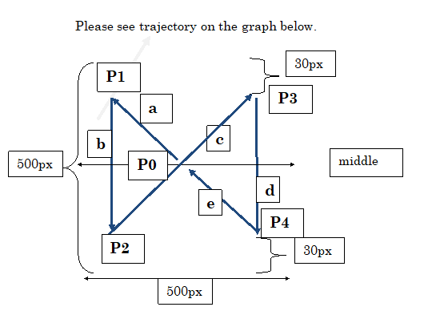

1. Based on using HTML5, add code to the ***moveSpaceShip*** function to play sound (from fly.mp3) while the spaceship is moving. When the spaceship stops, the sound stops.

(7 marks)

