 | HTML5 Test  Semester 1, 2022  ISCG6420 IWD  Part 3
School of Computing Electrical & Applied Technology | Date: Wednesday, 18 May 2022  Commencement Time: 6:00 PM  Time Allowed: 40 min  Marks: 33

Please fill in your name and your student ID.
Name: | student ID:

Instructions:

1. | This is semi-open book test. IWD demo website is closed.
2. | There are 3 tasks in this test. Each task is 40 min, you need to upload each task after 40 min. Submission will be allowed for 10 min only. You should complete all the tasks. You should attempt all the requirements.
3 | Please keep each test part in corresponded folder, for example Part_1. Please save all files during the test frequently. In the end of each 40 minutes, re-name your folder with your name (example: Part_1_Mary_popins), Zip this folder and submit.

Task | Topic | Possible Marks | Mark Awarded
Task 3 | Dynamically creating elements using DOM | 33

Task 3 Dynamically creating elements 33 MARKS

Instructions

- Using a file named display_score.html you will need to write a java-script functions. On button click it should invoke a Java-script function invoke a Java-script function display_inputs(). This function should dynamically create next seven check boxes within a table. Each dynamically created table cell must have a default text and a check boxes. Please refer to the image below.
(18 marks)
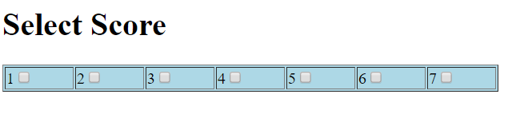
- You will need to write Java-Script function display_score(). The user can click a check box and message will be displayed. The text of the message is a string which state a score value. Please see examples below. (15 marks)
Example 1:
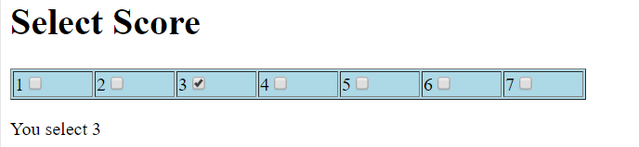

Example 2:

