Electronic Conferencing
With the globalisation of many companies, employees working on the same project are distributed around the world with team members in different cities, countries and continents. In order for everybody in the team to keep track of the project they need to meet regularly to keep in touch with each other, discuss approaches, solve problems and make decisions. While it may be useful for the project team to hold an initial face-to-face meeting this is not cost effective in the long term due to travel costs. To this end communications technology is a cheap and effective way of keeping the team informed and holding team meetings.

There are two types of electronic communications: synchronous and asynchronous
In synchronous systems participants communicate in real-time. The telephone is the most obvious example of a synchronous communications device but there are also a number of web-based synchronous communications solutions one example is Skype.

Asynchronous systems are messaging systems and have a time lag between the sender sending a message and the receiver receiving the message and responding to it. Email is the most obvious example of an asynchronous communications system but again there are a number of web-based asynchronous communications systems, the most common of which is a discussion forum where users post text messages to the group for comment. Comments are said to be ‘threaded’ and form a hierarchy. Below is an example of a thread from a discussion forum. When a user responds to a previous post it is indented to a new level.
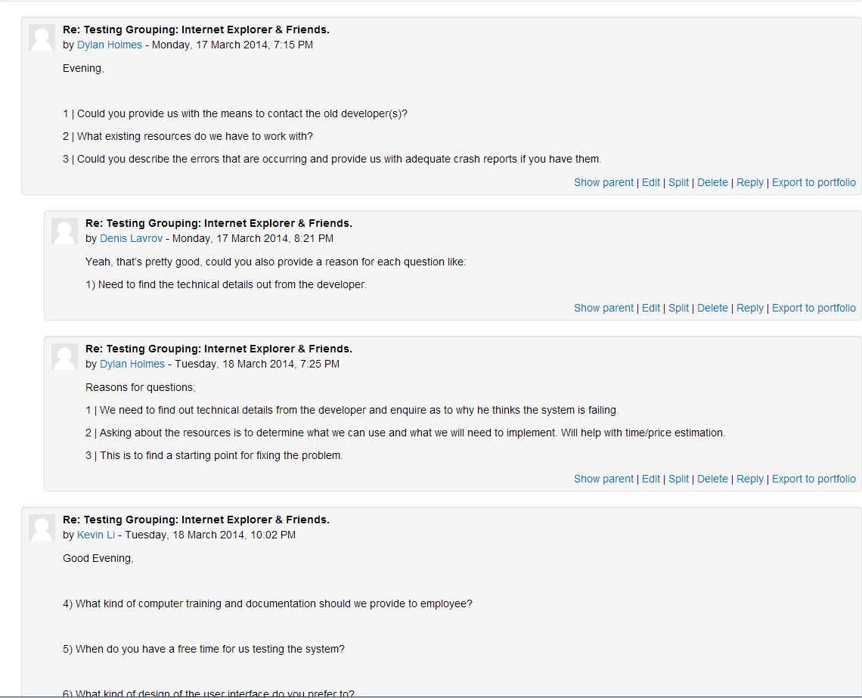

Asynchronous systems
Other than email the Moodle software provides several opportunities for asynchronous communications.
Your lecturer will create a group area for your group it will enable you to communicate with each other by posting messages to the forum and sharing information including file attachments. Moodle also supports a message facility where your message is visible to all users.

Another way to collaboratively develop work is through the Moodle Wiki facility. Here users can build a multi-page web site collaboratively. Users can add images, audio or video clips to their pages.

While the features of Moodle are no doubt useful in some circumstances they only provide asynchronous text-based communications which is little better than using email or texting or Instant Messaging (IM). Moodle does not support any kind of synchronous conferencing.

Synchronous systems

Audio conferencing

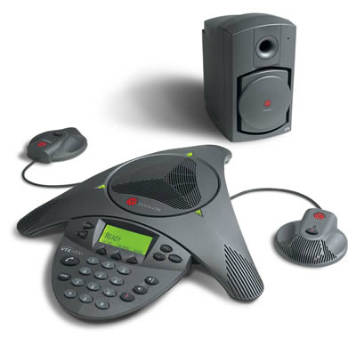
The simplest way for a group of people, who are geographically separated, to talk together is to use the telephone. There are a number of audio conferencing solutions that get users to dial in to a conferencing number, enter the meeting pin and join a conferencing session. Some of the conferencing companies have local toll-free numbers that the participants can dial. The organiser then picks up the toll charges from these connections. Special phones (see opposite) can be purchased that have multiple microphones to improve the audio quality when a number of people are in the same room.

If the other party happens to be available at the same time as you then IM, texting and even email can become synchronous.

Figure 1 - Polycom Phone Unit

Video conferencing

There are a number of ways that you can achieve video conferencing. The simplest is using products such as Skype with a web cam. This provides free, low quality conferencing with one or two people at each location. When more people are in one location, web cams do not really provide adequate image or sound quality but the options for rectifying this can get expensive. The best solution is to use specialised video conferencing equipment (see opposite). This is attached to a computer and normally set-up in a specially designed room. These devices are intelligent in that the software driving the video camera can detect when somebody in the room speaks and will turn and zoom the camera automatically to fill the frame with that person. When the software cannot detect any particular individual speaking or there are several people speaking then it automatically returns to a wide shot of the whole room. These video conferencing centres can be hired by the hour and provide high-quality hardware and software specifically designed for video conferencing.
Figure 2 - Polycom Video Conferencing Unit

Web-based conferencing
The web provides a great platform for conferencing. There are a number of products that support synchronous video and audio conferencing as well as file and screen sharing.

GoTo meeting is a Citrix-based solution that requires an application to be installed on the user’s PC. (See trap 3) It supports synchronous video and audio communications, file sharing and control of the meeting by any of the participants. The meeting originator can also pass control of the meeting to any of the participants. Products like GoTo Meeting are often used for remote support of users where the support person is given control of the keyboard and mouse by a remote user in order for them to investigate the cause of a problem. The only disadvantage of GoTo meeting is that once your 30 day free trial expires there is a cost to using it.

Skype: Many people are familiar with Skype. It provides free voice (and video)-over-IP and instant messaging facility to any other person connected to the service. You can also call land lines and mobile phones from Skype for a small charge. In terms of conferencing and file sharing you can add up to 10 people to a Skype session and share your screen and files with the group.

Google+: Google+ also provides facilities for sharing and communications. You can join one of the public communities that are available https://plus.google.com/u/0/communities. These are asynchronous forum-type discussions where users post messages and share files with the group. This facility is similar to Moodle groups but Moodle groups are limited to Unitec students from a particular course. Google+ also allows people to create their own private community and invite their friends.

In terms of synchronous communications Google+ supports ‘hangouts’ where groups of users can have private or public audio or video communications. The Google services support mobile devices.

Facebook: Facebook supports asynchronous public and private forum-type discussions called ‘groups’ similar to Google+ and Moodle. Users can exchange text, photo and link to Youtube videos.

Pros and Cons
The benefits of the phone-based conferencing system is that no additional technology is needed. So anybody can join the meeting, all they need is a phone. Web-based systems are able to provide video and file and screen sharing in addition to audio conferencing but do require network ports to be open. This can be a problem on a company’s fire wall particularly for companies such as Banks who take security very seriously.

Tips and traps for electronic conferencing
- During face-to-face meetings people use visual cues to know when to speak so for example if you ask the group of ten people “Are there any questions?” the participants will generally take it in turns to ask questions or raise their hand to ask a question. During an electronic conference participants lose visual cues so people either keep interrupting others or wait too long for a pause in the dialog and end up not asking their questions. To ensure everybody in an electronic conference is able to participate, the chair should invite participants one at a time to speak. So for the group of ten people the chair should go around the virtual table asking each person individually if they have any questions.

- Don’t expect the same level of Internet access in the work-place that you experience at Unitec. Companies frequently disable the ports used by web-conferencing software. Thus if you want to run a web conference make sure you test the access levels of the participants before the conference. It is unlikely that you will be able to get the IT services in their companies to enable the ports that you need so you’ll need a plan ‘B’ which is usually emailing your presentation and using phone conferencing.

- In our description of GoTo Meeting we said it requires a small application to be installed. Be aware that users in corporate environments will usually not have the rights to install software on their computers. Most IT departments will lock-down the desktop for users in order to reduce administration costs.

